

**FILE MANAGEMENT SOFTWARE**

High Level Design Version Draft

**Team members**

|  |  |
| --- | --- |
| **Employee id** | **Name** |
| 46291226 | SWETHA DEVISETTY |
| 46290147 | BHARGAVI DUMPA |
| 46290148 | ROHITHA ATTILI |
| 46290149 | DEVI SARANYA ADAPA |
| 46290150 | JYOSNA SRI KALABATTULA |

# Table of Contents

**High Level Design**

|  |  |
| --- | --- |
| 1. Introduction | |
| 1.1 | Purpose |
| 1.2 | Scope |
| 1.3 | Overview |
| 2. General Description | |
| 2.1 | Product Perspective |
| 2.2 | Tools used |
| 2.3 | General Constraints |
| 2.4 | Assumptions |
| 2.5 | Special Design aspects |
| 3. Design Details | |
| 3.1 | Main Design Features |
| 3.2 | Standards |
| 3.3 | Data Flow Level-0 |
| 3.4 | Data Flow Level-1 |
| 3.5 | High Level Design |
| 3.6 | User Interface |
| 3.7 | Error Handling |
| 4 | Supportability |
| 4.1 | Design Constraint |
| 4.2 | Usability |
| 4.3 | Reliability & Availability |
| 4.4 | Performance |

# High Level Design

## Introduction

### Purpose

This High-Level Design (HLD) Document explains the architecture used to develop a system. The architecture diagram provides an overview of an entire system, identifying the main components that would be developed for the product and their interfaces.

### Scope

This document provides a comprehensive high level design overview of the File Management Software. It highlights the high-level flow of the functionalities of the system and serves as an input to the low-level design documents that would further elaborate on the proposed system design.

* 1. **Overview**

This HLD Document is arranged in the following format:

Section1: Introduction

A brief explanation about the purpose, aim, scope, and design format of the proposed project.

Section 2: General Description

This section is all about the general constraints, assumptions, and design aspects associated with the proposed project. The product perspective will give an overall description of the simulator.

Section 3: Design Details

This section documents the detailed design of all modules associated with the development of the proposed simulator.

## General Description

### Product Perspective

File management software is an application that enables users to create, store and access files on a device like desktops or laptops. Initially file management systems were also designed to manage the files. E.g., WinSCP, FileZilla, Microsoft OneDrive. User registration allows the user to register themselves to upload the files, files that are already uploaded can be downloaded after login. The delete file allows the user to delete files that we have uploaded. Users can edit the description and details of our profile.

* 1. **Tools used**
  + Valgrind

### General Constraints

**User Characteristics:**

User should be familiar with terms like login, logout.

**General Constraints:**

A complete network is required for Linux and windows operating system.

### Assumptions

1. Working of Client and Server Application through following requirements:

* IP address – internet address
* Port number – port number - 4444

2. We require socket system call to establish connection between client and server.

3. We are using man, time commands from Linux systems to establish file management.

### Special Design aspects

One of the design aspects is that the software was arranging the files and folders hierarchically.

## 3. Design Details

### Main Design Features

The main design features include five major parts: supportability, design Constraint, usability, Reliability & availability,and Performance.

### Standards

* Security – This security protects corporate servers against malicious uploads.
* Redundancy – Data Redundancy refers to the practice of keeping data in two or more places within a database or data storage system.

### Data Flow Diagram (Level - 0)

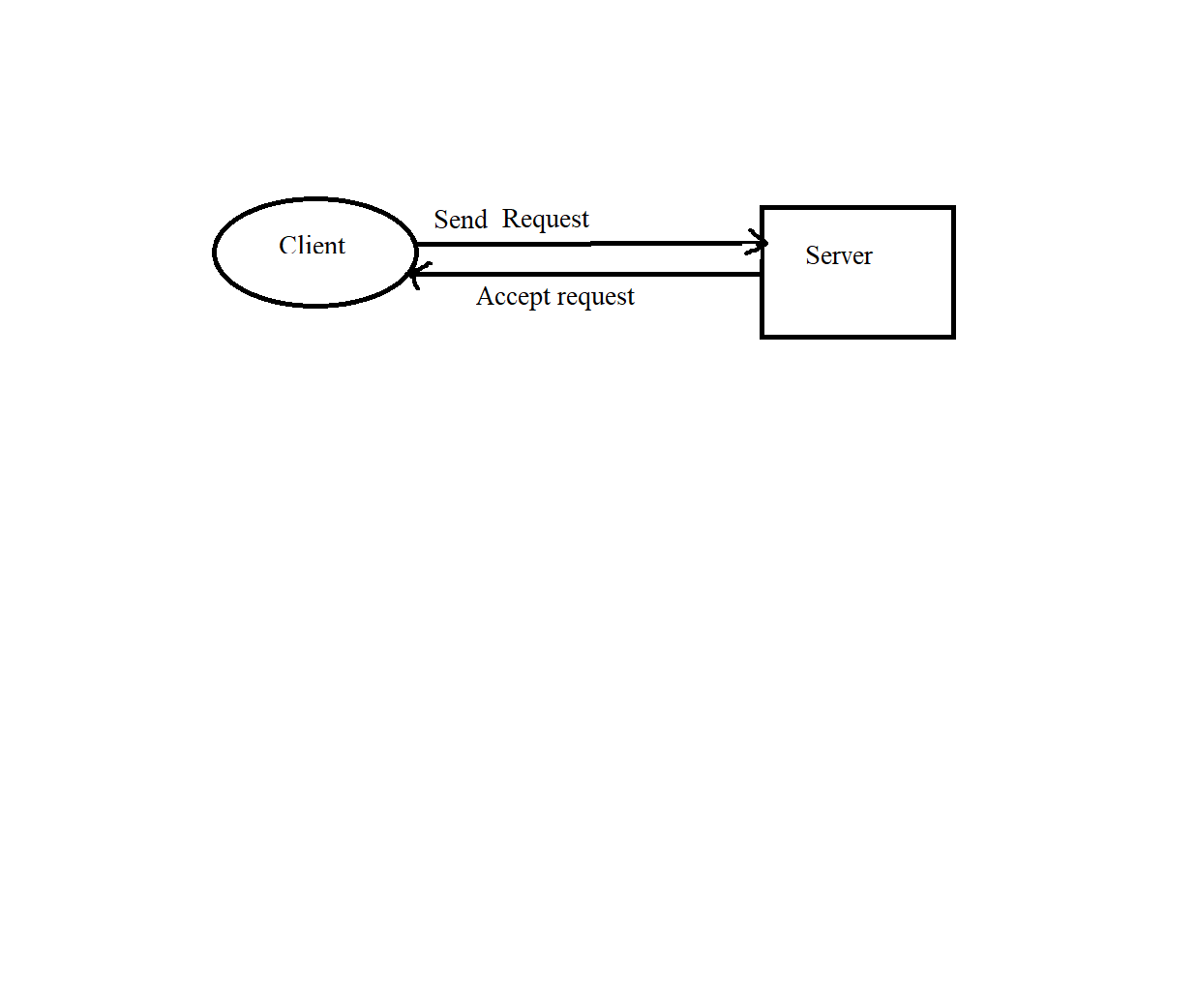

* 1. **Data Flow Diagram (Level - 1)**

### High Level Design

* 1. **User Interface**

Menu Driven interface.

### Error Handling

The System can detect errors when a file is opened, when a program device is acquired or released, during I/O operations to a file, and when the file is closed. When appropriate the system will automatically try to run a failing operation again

Up to a try again limit.

1. **Supportability:**

The system is easy to use.

**4.1 Design Constraint:**

The system is built using System Programming in C.

**4.2 Usability:**

File Management Software is used to upload, download, disolay or delete files.

**4.3 Reliability & Availability:**

The application is available 24/7, when the client wants to use it to access the files. The client should simply login.

**4.4 Performance:**

The file management works on both the server and client’s terminal.